**Documentation for creating Certifiacte Signing Request for SSL Certificates through NameCheap:**

The following is the code that was typed on the Ubuntu system’s terminal:

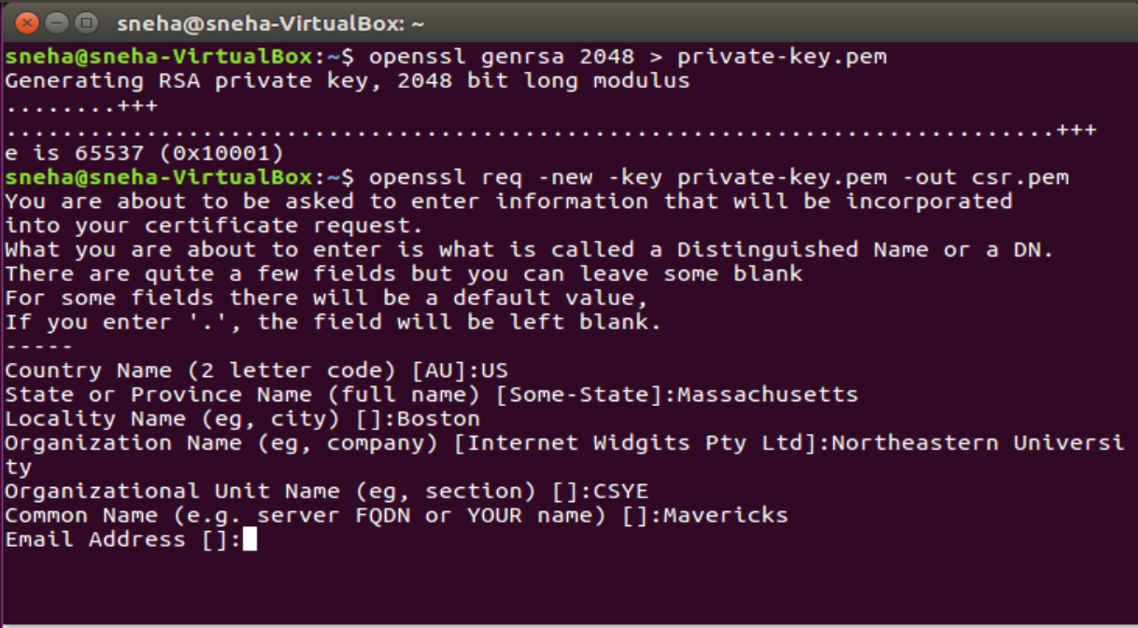

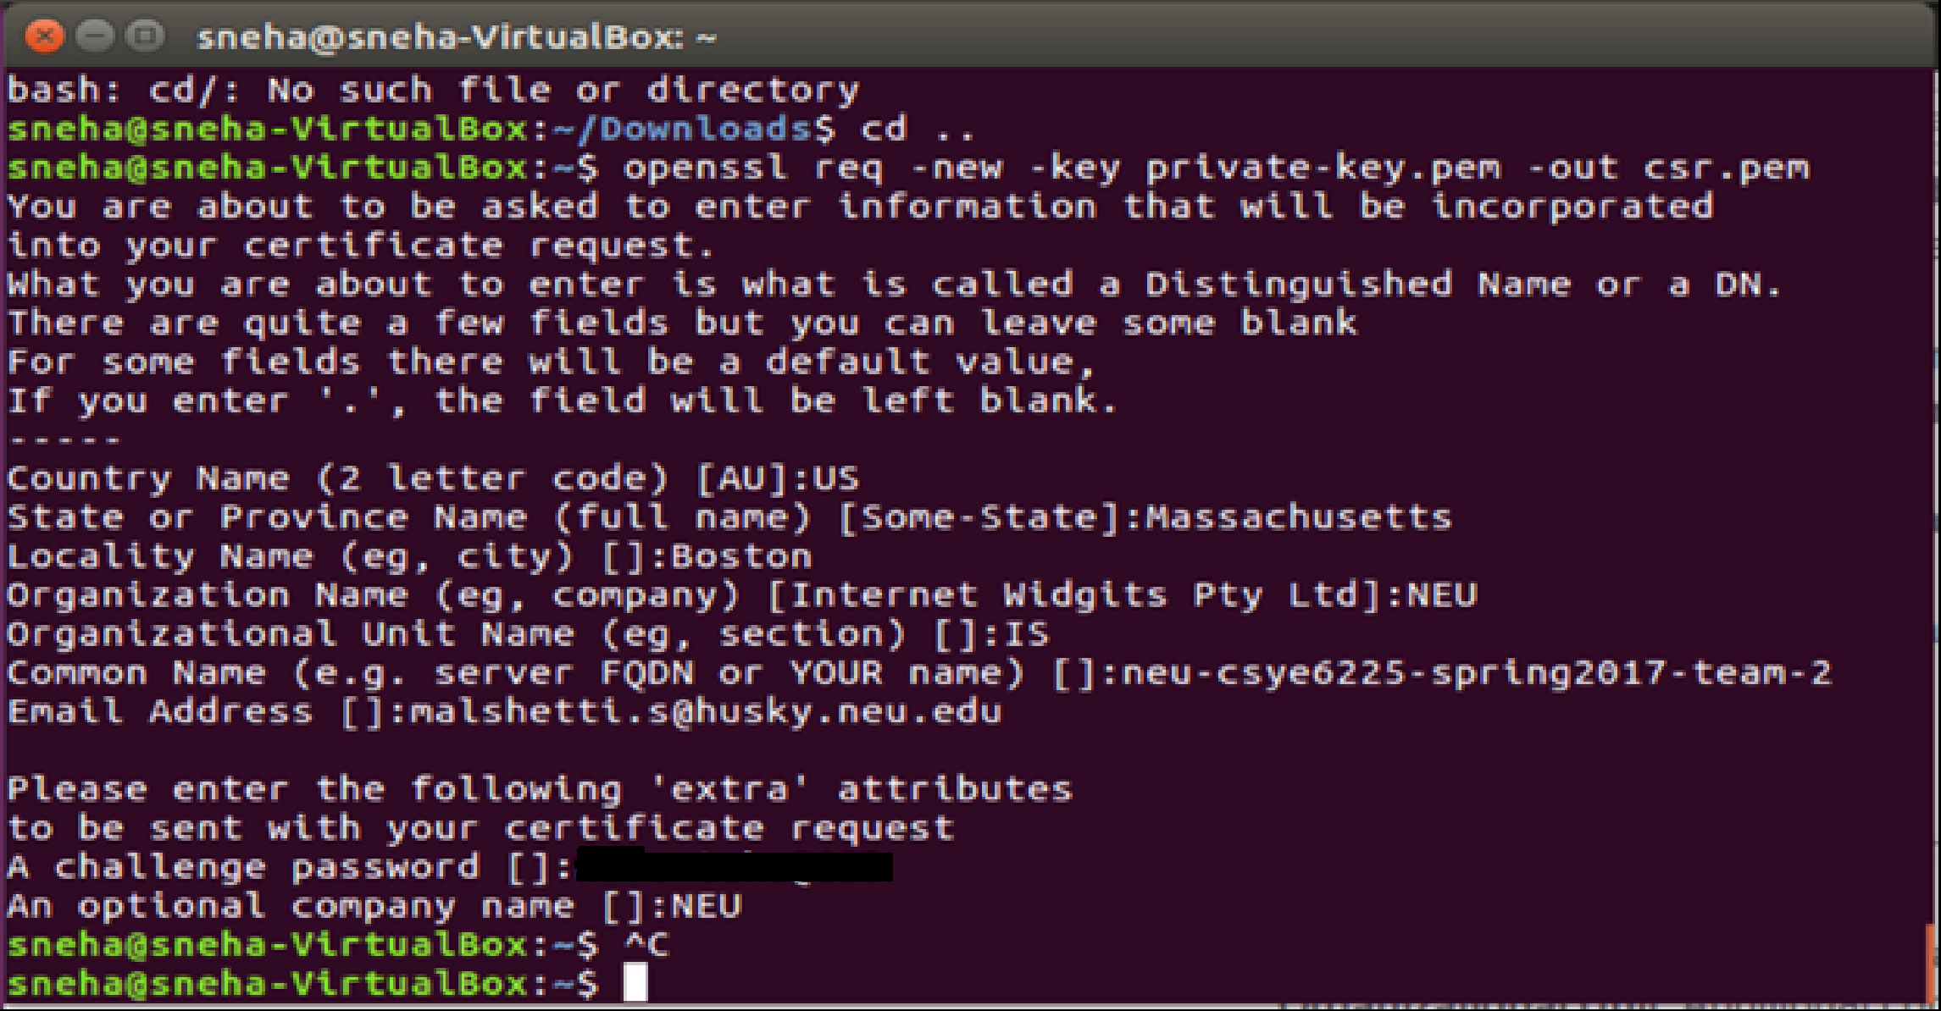

Open Name cheap and on the dashboard click on product list, where you will find the SSL certificate in the dropdown. Click on the SSL Certificate option to see the window as below.

Click on the “Activate” button.

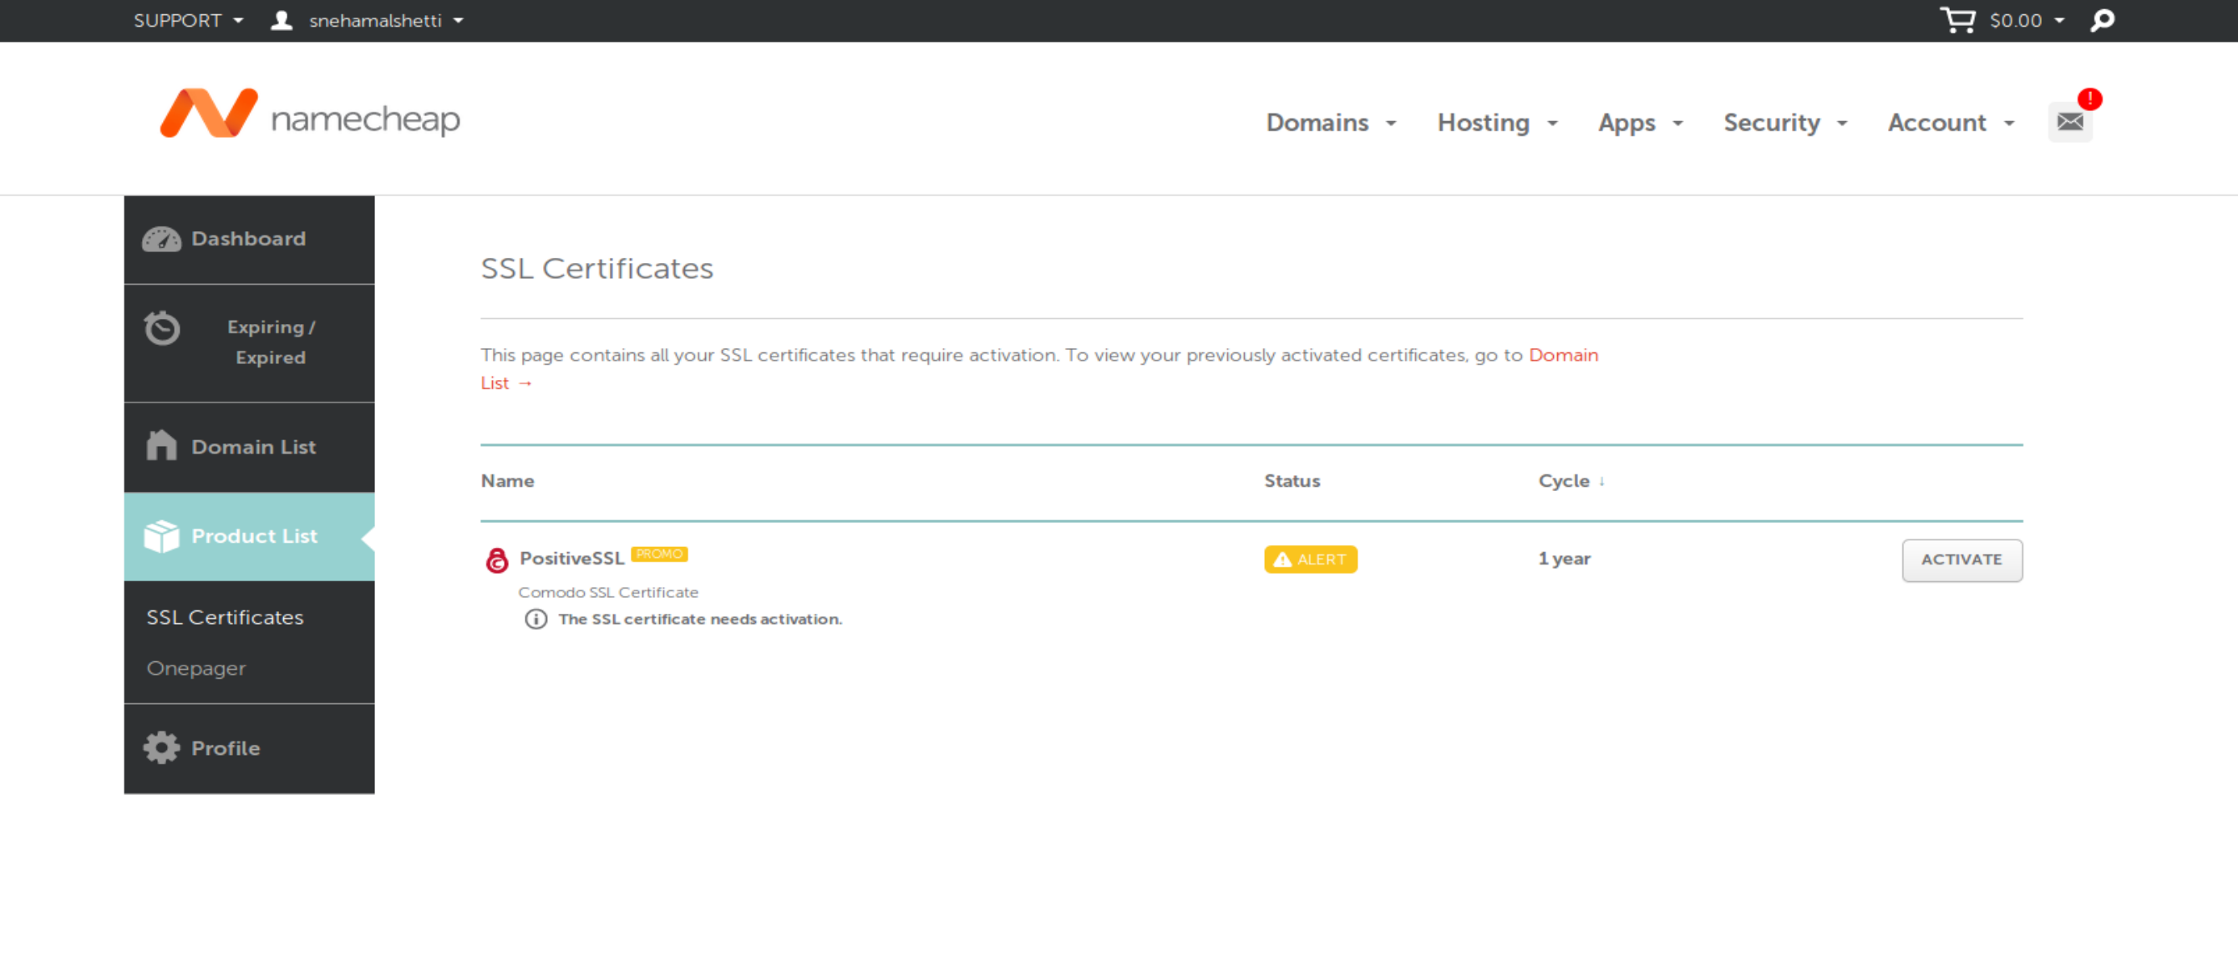

From the CSR. Pem file generated, pick out the encoded lines and paste them here. In Server type drop down menu choose “Apache, Nginx, cPanel or other” option.

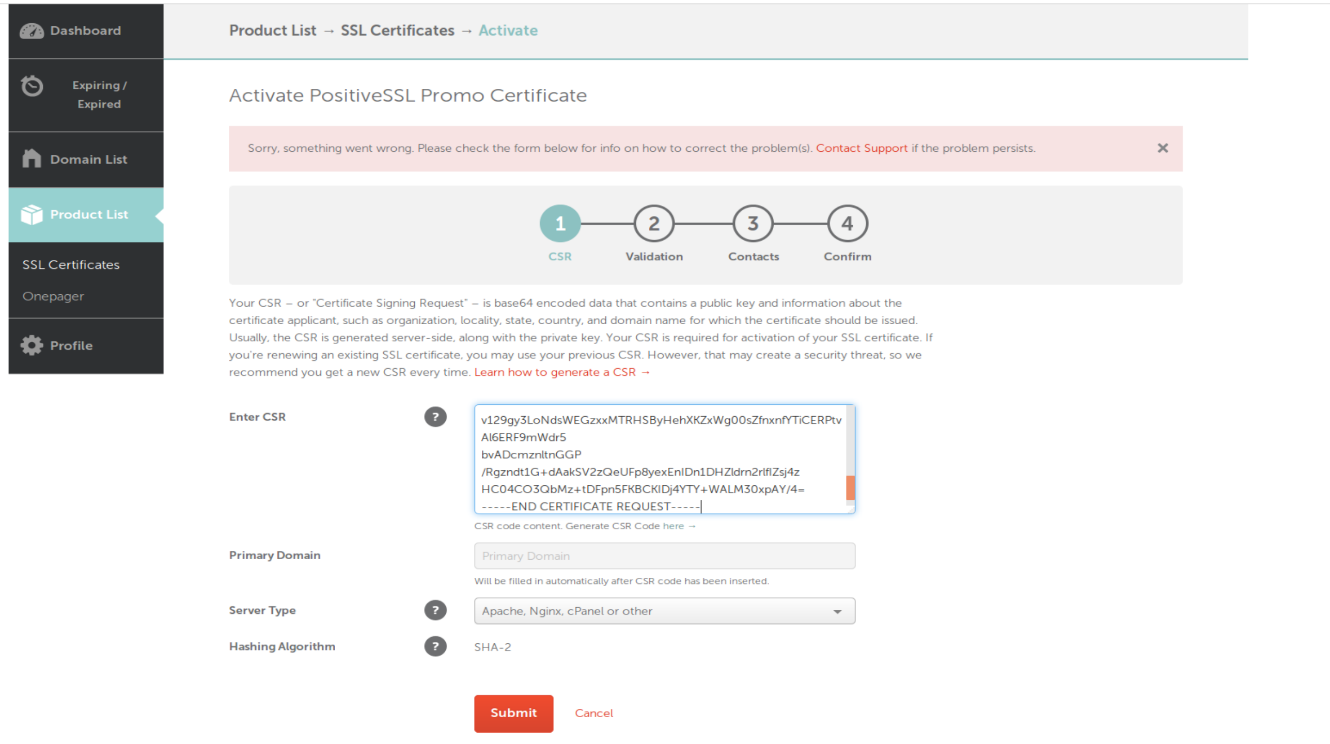

Click on the “Next” button.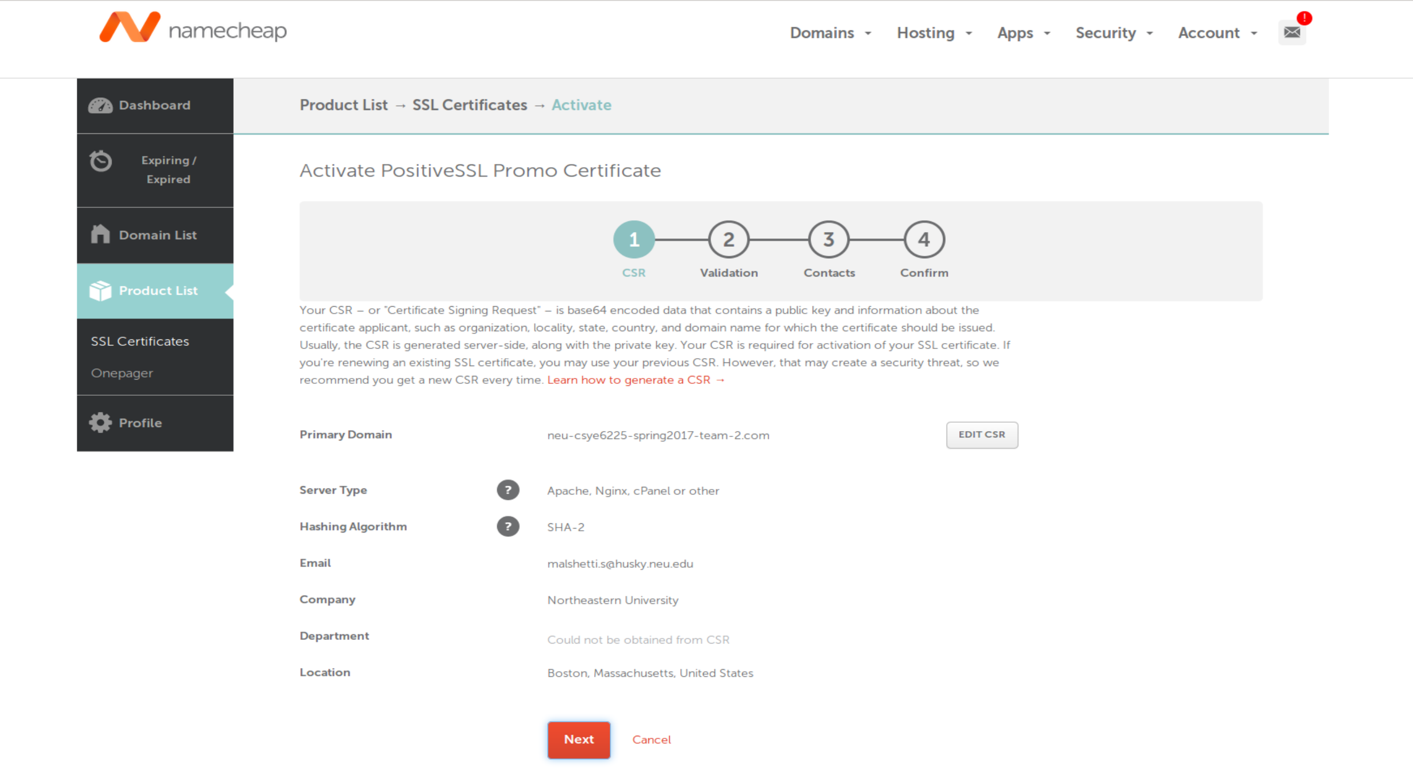

Decide on DCV method and click on “Next”.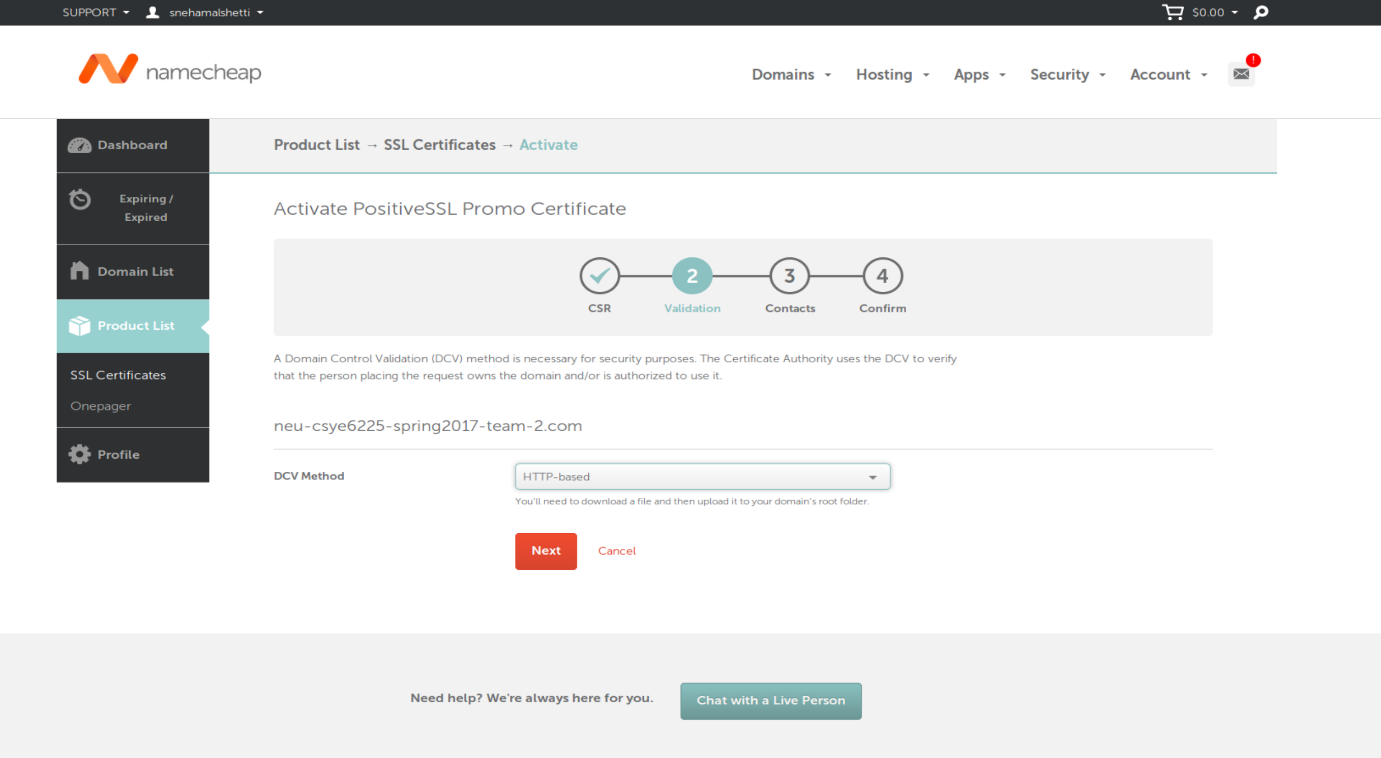

Fill in the following details and click “Next”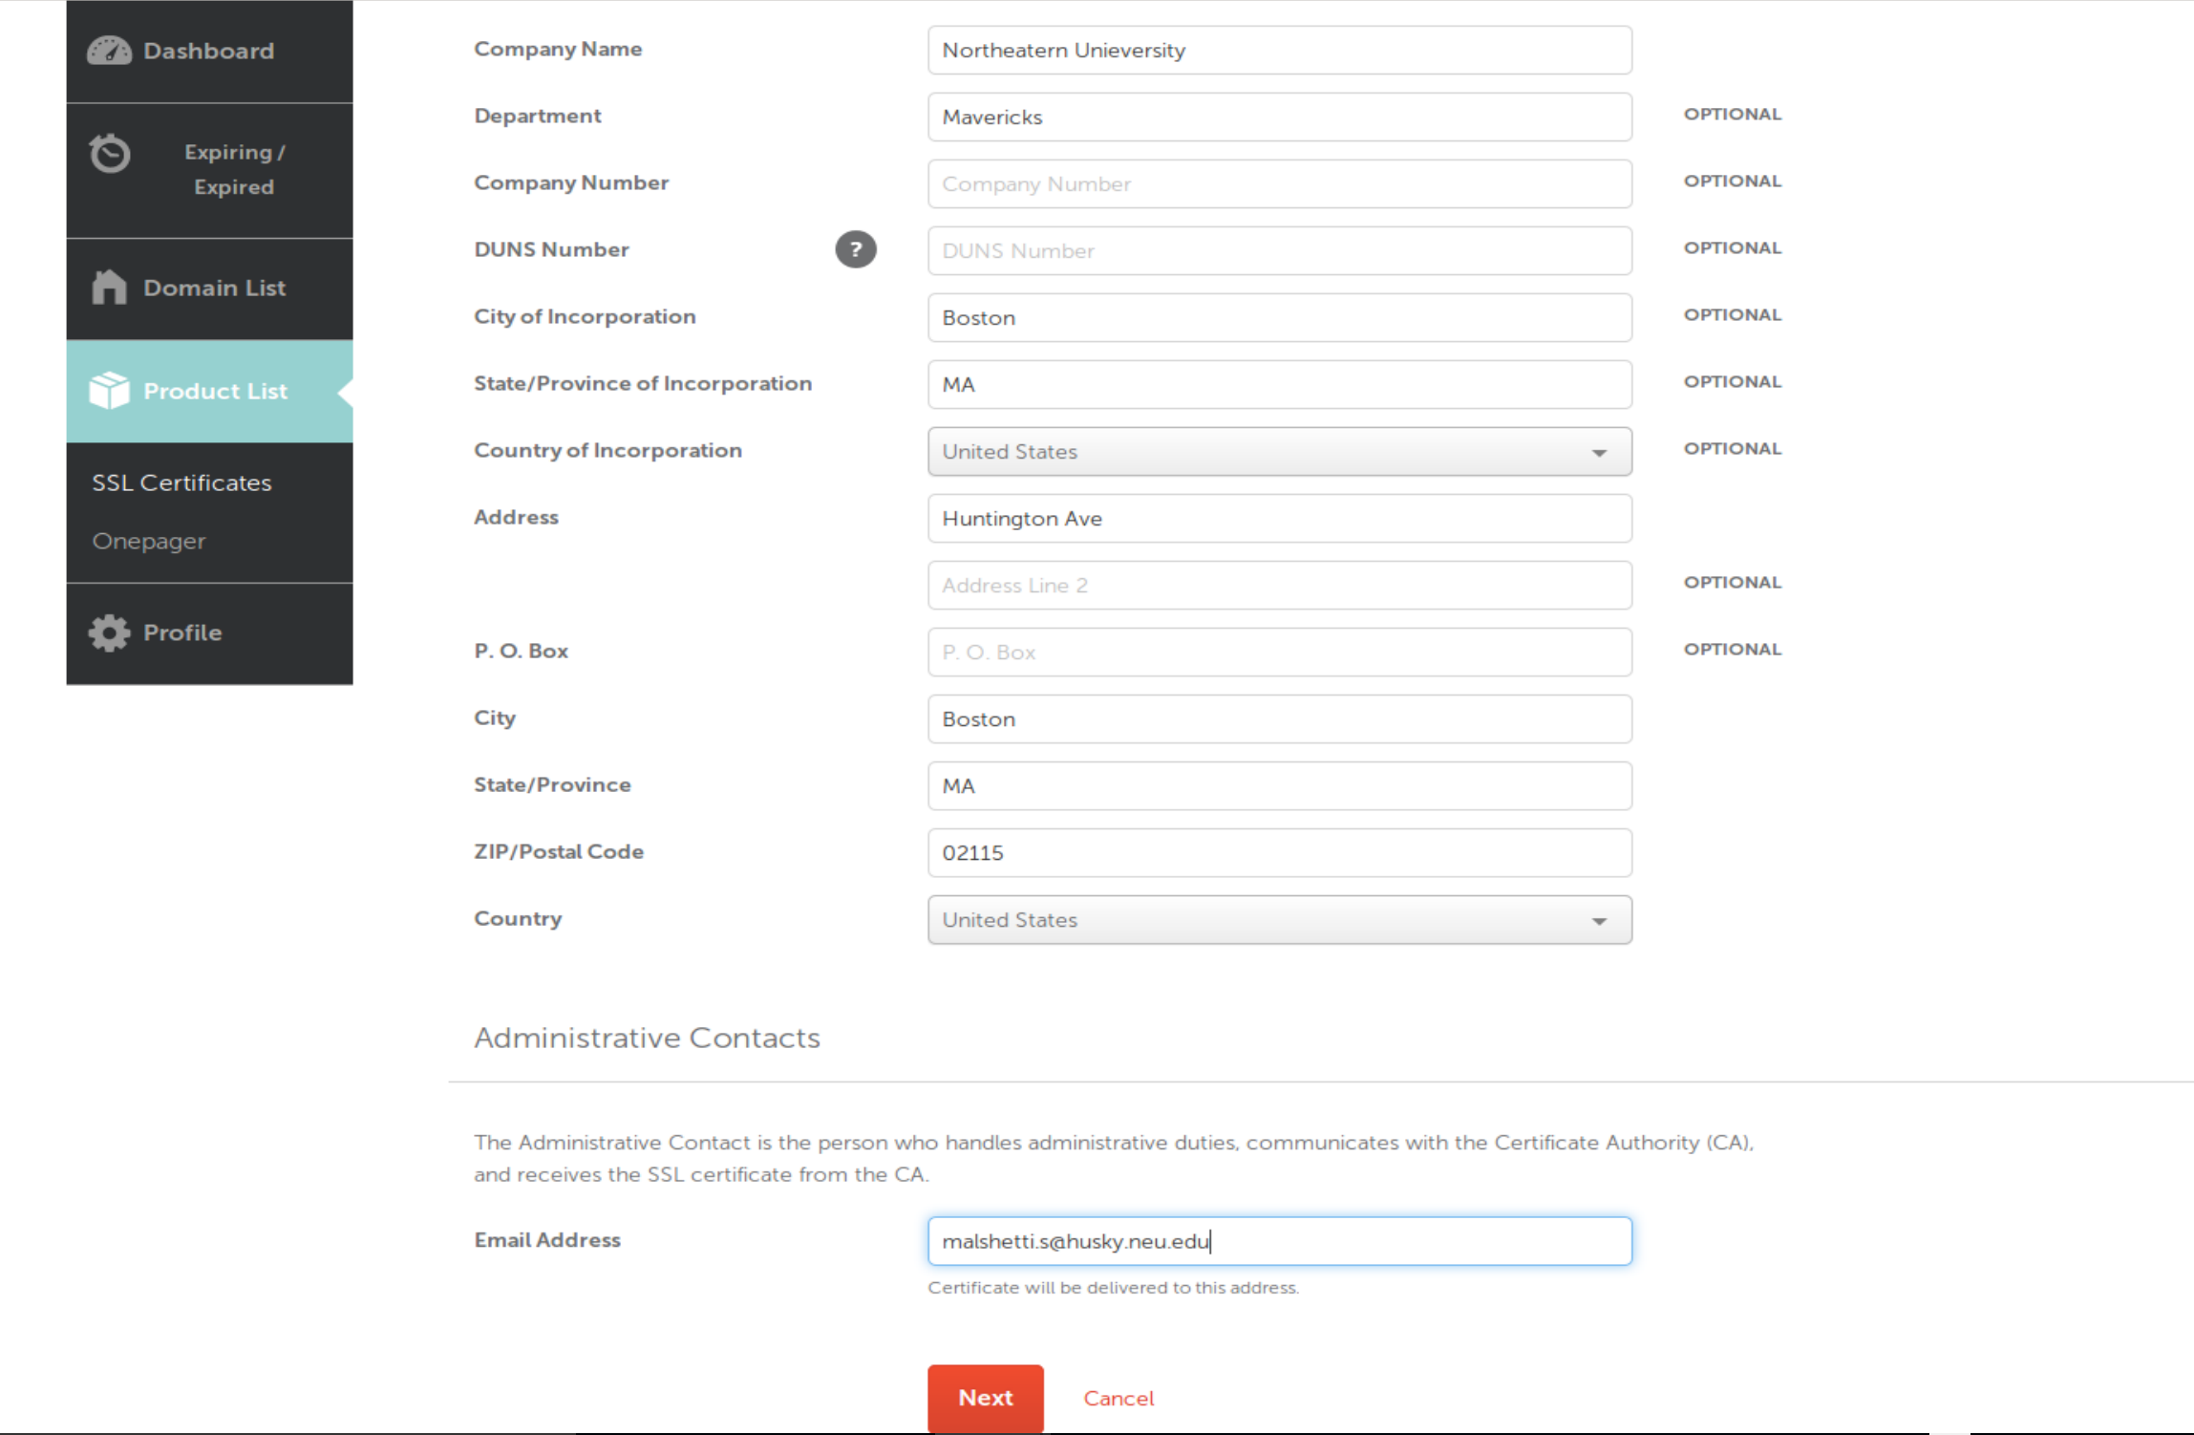

Click on “Confirm”.